Comcast Telecom Consumer Complaints

**Domain:** Consumer

**Solution:**

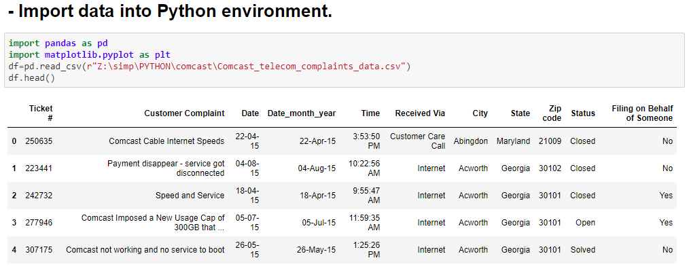

Dataset can be imported to the environment using pandas data frames.

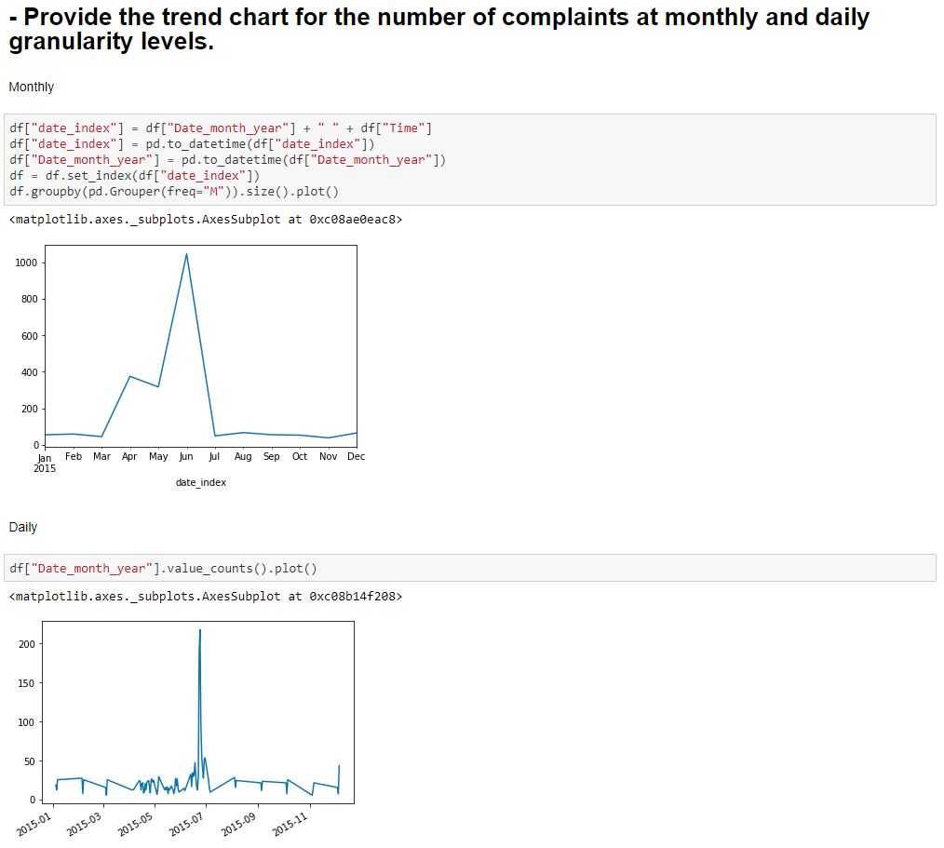

Trend chart can be plotted using plot() function of matplotlib based on the Date column.

We can see the trend of complaints received on monthly and daily levels

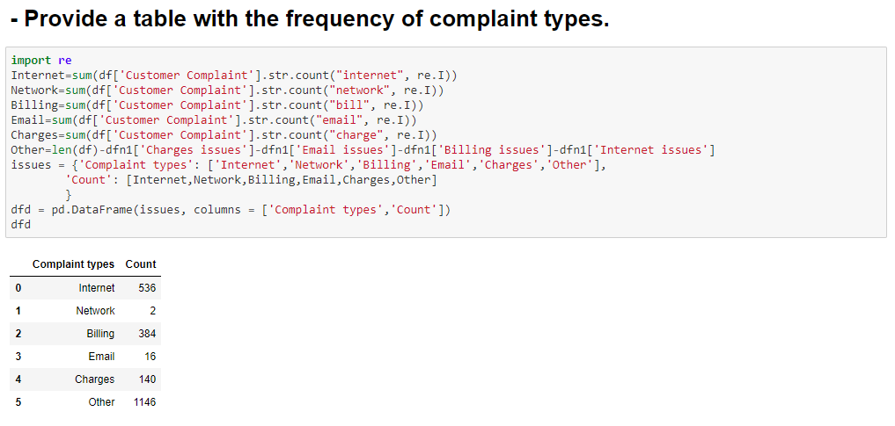

Table with frequency of complaint types can be obtained by searching the column Customer Complaint sing regular expressions.

Frequency of different types of complaints can be observed.

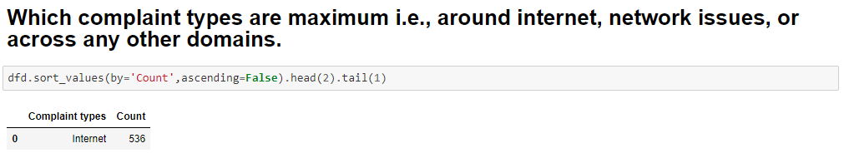

Maximum can be obtained by getting the first element in a descending sorted list.

We can actually see ‘Other’ category containing different kinds of complaints with most count, however if we were to consider a single category, **complaints are maximum around issues related to ‘Internet’**

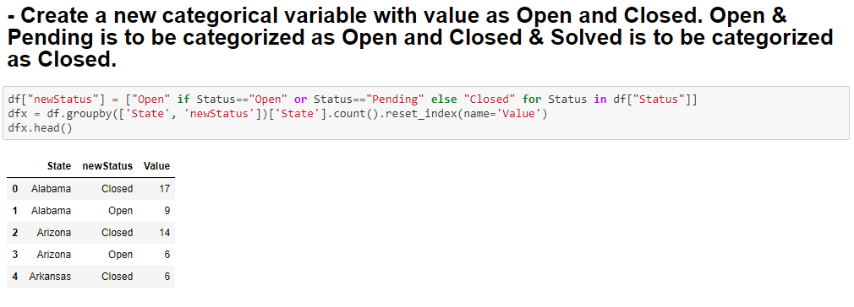

Categorical variables can be created using data frames and if else loops.

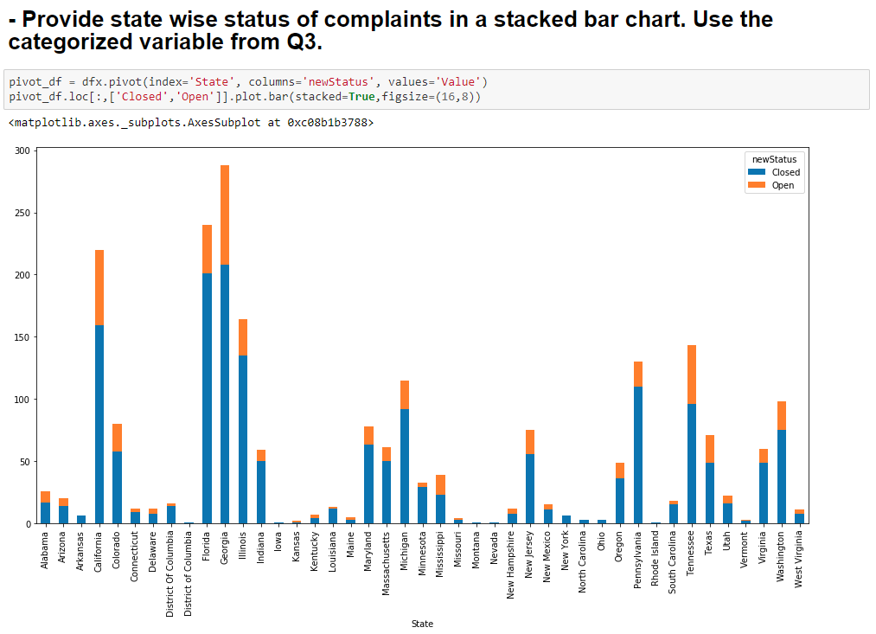

State wise complaint status can be plotted using plot.bar() function of matplotlib based on the categorical variable column.

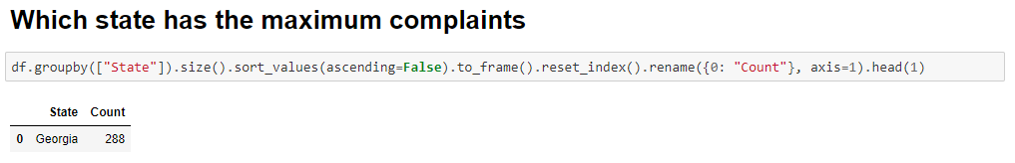

Maximum can be obtained by getting the first element in a descending sorted list.

We can see that **‘Georgia’ state has the most complaints.**

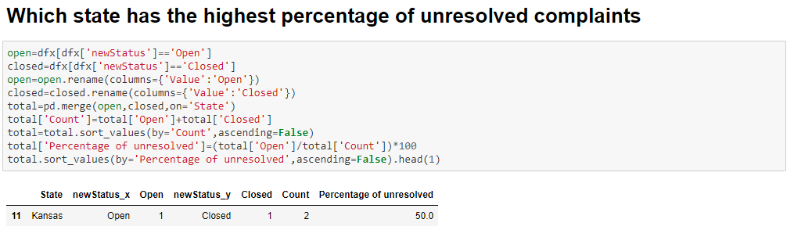

Unresolved complaints % can be obtained by total Open / total Count and by getting the first element in a descending sorted list.

We can see that **‘Kansas’ state has the highest percentage of unresolved complaints.**

(But only because its having only 1 open and 1 closed it has the highest percentage)

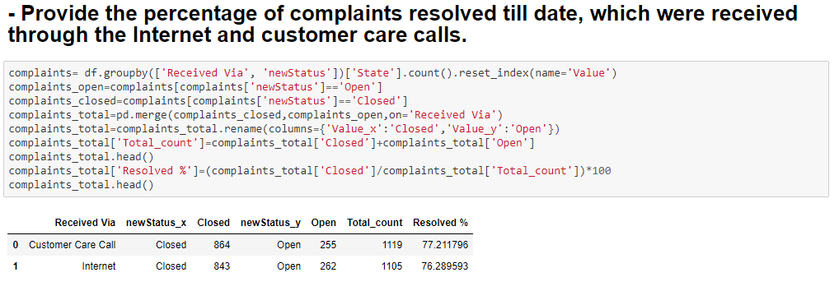

Complaints resolved variable and groupin can be created using data frames and conditional formatting and resolved complaints % can be obtained by total Closed / total Count

We can observe the percentage of complaints resolved till date, which were received through the Internet and customer care calls.

*************************************************************************************